**Nicholas Reggi Portfolio**

Group Seven

Nicholas Reggi

https://github.com/n9738525/IFB299Pump

**Artefact 1** – Activity Diagram

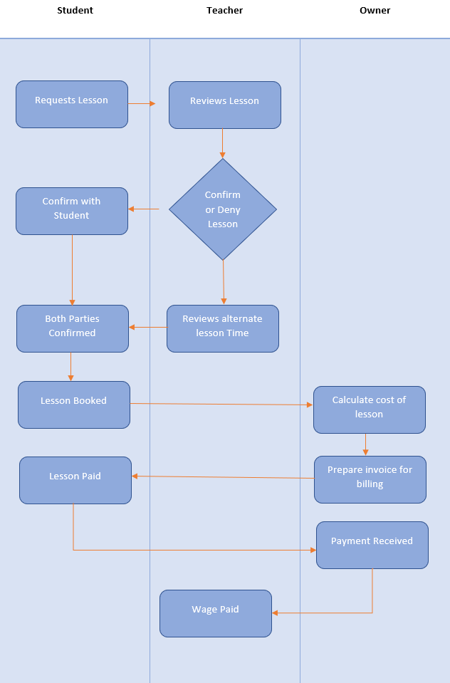

Activity diagrams enable users to capture the dynamic behaviour of the system. It allows for the activity flow of the process to be analysed accurately and easily displays parallel processing. It also displays the sequence from one event to another, including all the different parties and how they relate.

This diagram was presented to the development team to assist with ideas process on how we would expect an activity to flow. The development team was initially confused about the general structure and sequence of events, this diagram was very useful in explaining to them the processes, in which impacted the final designs.

**Artefact 2** – UML Diagram

A use case is a graphic representation of the interactions and elements of a system. There are used to clarify, identify and organise a set of system requirements. They display the actors individually, and their specific roles according to the system. It also shows the relationships between the actors.

The UML diagram allow is a partial representation of the booking lesson system. This diagram assisted with the development team to gain a better understanding of the different information that is needed to flow through different actors and systems, in order to make the purchase.

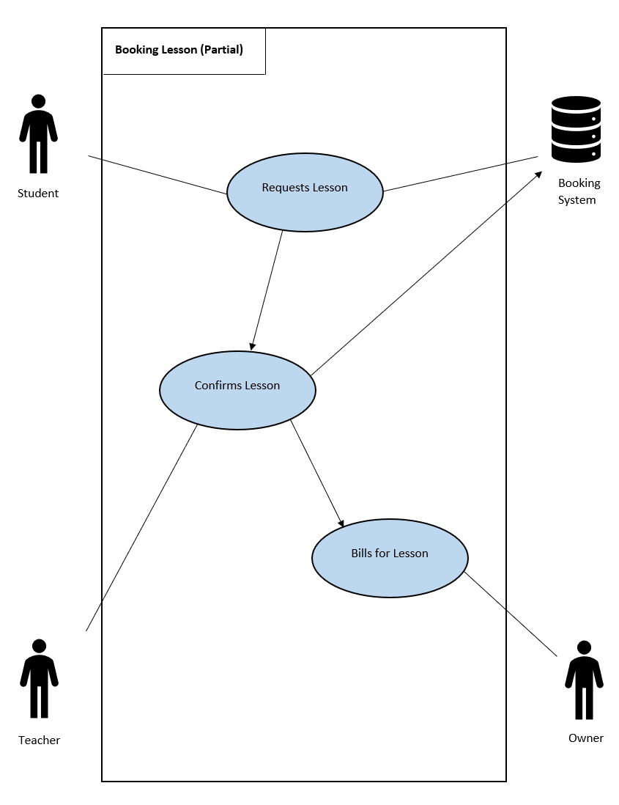

**Artefact 3** – Test Cases

A use case is a description of a particular process of a system by an particular user. It is mainly used in developing testing or on an acceptance level. Planning the testing allows the development team to prepare for what key aspects of the system are to be tested, and for how long the activity will take to complete. The goal of using test cases is to execute real world use cases to determine if there if software defects within the system.

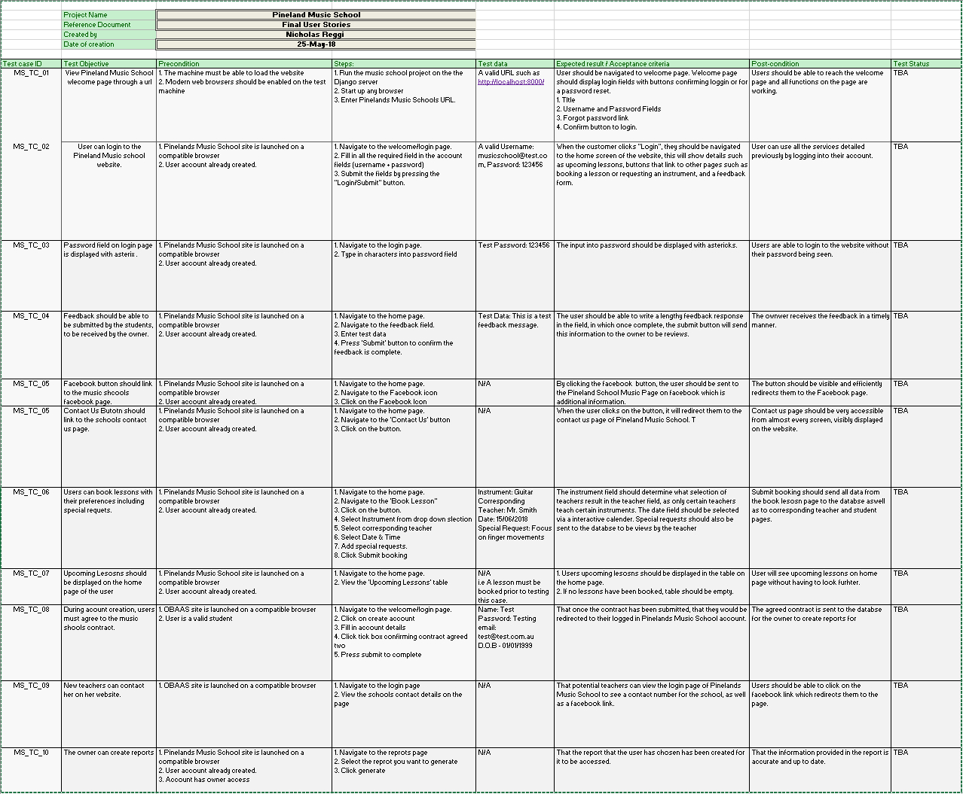The development team was not ready with the required functionality within the system to test the test cases at the time of completion, so the test status has been marked as TBA. The testing team will progress through the test cases noting if the test has been successfully completed. This will give an idea on the effectiveness and functionality of the system according to the clients needs.

**Artefact 4** – Feedback for User Interface

Feedback allows the team to evaluate the current design aspect of the system, according to the systems needs. It allows the client to advise the team what they want changed/altered to fulfil the clients goal. User interface can improve user satisfaction, by ensuring that the user interface is coherent and efficient and works to its desired objective.

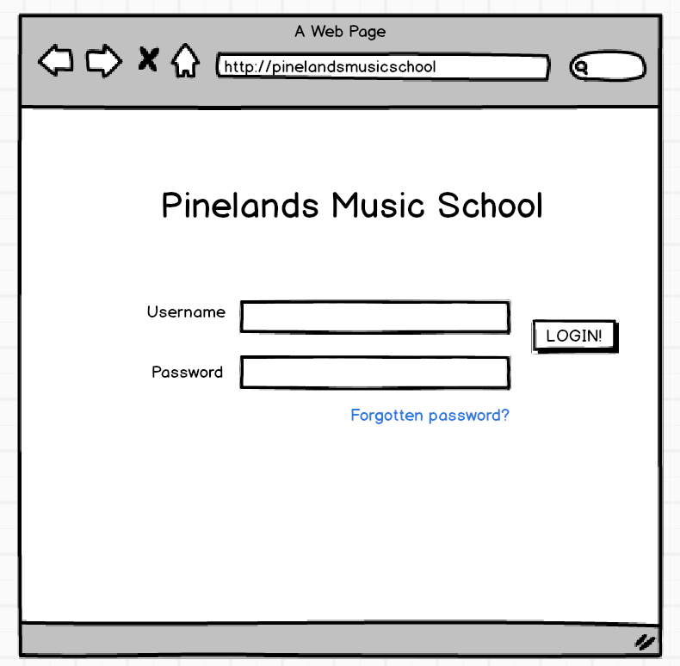

**Feedback from client + development team**

Login Page:

* Contact no as well as Facebook link to be added
* Create account button to be added
* Graphic logo of school name rather than text
* Ensure the page is graphically appealing

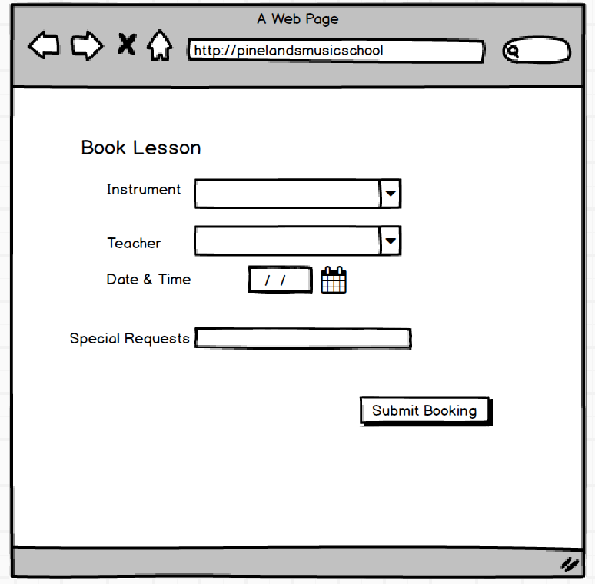

Lesson Booking Page:

* Add Pinelands music school graphics
* Add field for language requests, not to be included in the special requests field.
* The ability to select predetermined lesson times

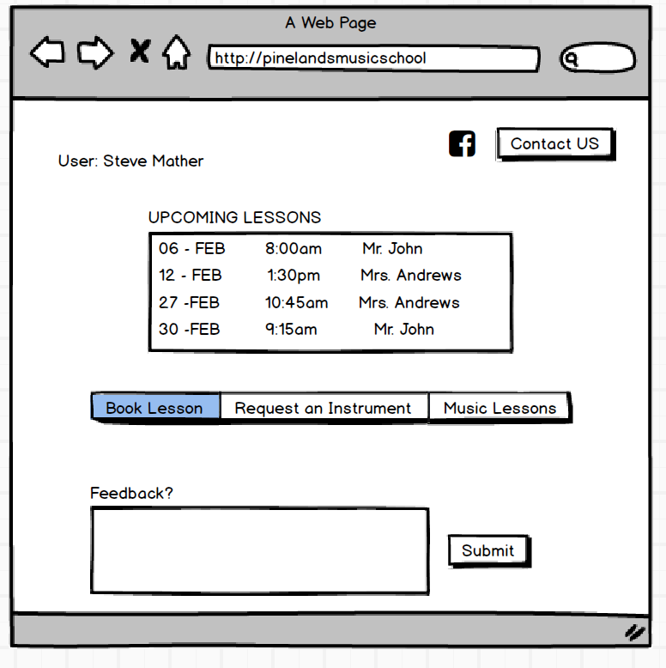Home Page:

* Add Pinelands music school graphics
* Add other social media accounts such as twitter, LinkedIn, Reddit
* Reducing the size of the feedback field
* Display the users account number next to their name for easy reference
* Individually defined buttons instead of one continuous bar.

The feedback given by the client and development team contributed to the changes made in to the user interface design. It ensured that the UI was to the clients standard. It also allowed us to gain another aspect on how the same data can be displayed more efficiently. The feedback given on each of the pages was analysed and the necessary changes were made to the system after the consultation.